HERTFORDSHIRE SAFE FOOD PACK

A FOOD SAFETY MANAGEMENT
SYSTEM FOR BUSINESSES
Version 3. July 2025

For a fully editable version of this pack or for further information please contact bbfa@hertfordshire.gov.uk
Specific guides for vacuum packing, cake making and a wide range of other food areas including standalone record tables are available on the BBfA Business Toolkit here: Better Business For All | Hertfordshire Futures

Contents Page
1. Introduction 4
2. Instructions on how to use the pack. 5
3. Critical Controls Decision Tree 6
4. Flow Chart (Process Steps) 7
5. Description of Operations 8
6. HACCP Control Chart (Key steps & control measures) 10
7. Information Sheets (Critical Control Points - CCP) 21
7.1 Purchase and Receipt 21
7.2 Storage (cold holding, frozen storage and dry goods) 21
7.3 Preparation 21
7.4 Cooking 21
7.5 Chilling 21
7.6 Storage (cold holding) 21
7.7 Post Preparation 21
7.8 Reheating 21
7.9 Service (including chilled/ambient holding/display) 21
7.10 Delivery 21
7.1 Purchase & Receipt 22
7.2 Storage (Cold Holding, Frozen Storage And Dry Goods) 23
7.3 Preparation 25
7.4 Cooking 28
7.5 Cooling 30
7.6 Storage (Cold Holding) 32
7.7 Post Preparation (Further Preparation After Cooking) 34
7.8 Reheating 36
7.9 Service (Including Chilled/Ambient Holding/Display, Hot Holding.) 37
7.10 Delivery 39
8. Food Safety Pre-Requisites 41
9. Record Sheets 51
9.1 Delivery Record 52
9.2 Cold Food Record 53
9.3 Hot Temperature Food Record 56
9.4 Allergen Matrix 58
9.5 Allergen Management House Rules 59
9.6 All-In-One Record 60
10. Standard Operating Procedures (SOP’s) 64
10.1 Allergens SOP 65
10.2 Preventing cross-contamination 70
10.3 Procedure for Safe Production of Sushi and Sashimi SOP 72
10.4 The Inspection 77
10.5 Management 77
10.6 Hygiene 78
10.7 Structure 80
10.8 Other Considerations 82

P

Introduction
A Food Safety Management System (FSMS) is a systematic approach to controlling food safety hazards within a food business in order to ensure that food is safe to eat.
This comprehensive food safety pack gives a practical approach to food safety management.
- This will enable a food business to identify the key hazards within their operation and to establish the critical controls needed to ensure food is safe.
- It will enable businesses to comply with requirements imposed by legislation, approved codes of practice and relevant industry guidance.
- It will help businesses include the level of detail required taking into account the size of the business, the nature of the food operation and the key food safety risks.
- It is a legal requirement to demonstrate that critical controls relevant to the business are identified and effectively controlled (The principles of Hazard Analysis Critical Control PointHACCP). This pack will include the key elements of ‘validation’ and ‘verification’ described in Article 5 EC 852/2004. Validation: assurance that the HACCP system will produce safe food.
Verification: implementation of measures to determine compliance with the HACCP Plan.
The current ‘record keeping section’ contains various forms which, when completed, will help the business to demonstrate that critical checks are being carried out and this will supplement the FSMS.
A comprehensive and implemented FSMS will help a business to comply with food hygiene regulations, achieve good hygiene ratings (under the FSA’s Food Hygiene Rating System) and above all will ensure that all food produced/handled is safe to eat.
Page 4

Instructions on how to use the pack.
This pack is an interactive system which requires input from the food business operator (FBO). The FBO will need to look at the steps relevant to their business and decide which controls are critical. This pack will help identify those steps from the flow chart and HACCP control table then choose which controls are necessary. There are some basic definitions that need to be understood before using this pack.

HACCP
A recognised system for managing food safety based on a set of principles including the identification of hazards and implementation of critical controls.
Process Step
Any stage in the food operation, from purchase of ingredients through to serving the customer.
Examples include receipt, chilled storage, preparation, cooking, cooling, hot and/or cold service.
Hazard
Anything that may cause harm to your customers through eating your food – microbiological (e.g.
bacteria, viruses), physical (e.g. glass), chemical (e.g. cleaning agent) or allergens (e.g. nuts).
Critical Control Point (CCP)
A step at which control must be applied in order to prevent or eliminate a food safety hazard or reduce it to an acceptable level as it will not be removed at a later step. Examples include cooking to 75ºC, the chilled storage of high-risk food, preparation after cooking.

Page 5

Critical Controls Decision Tree
There are key steps that will produce safe food.
If the control fails will a hazard occur i.e., illness or injury?

Will a subsequent step eliminate or reduce the hazard to an acceptable level i.e. cooking?

Control point
(not critical)

Critical Control Point
(CCP)

Will the control reduce or eliminate hazards at this step?

IF SO CONTINUE
^{YES}
YES
NO
NO

IF NOT, THIS IS NOT A CCP

Page 6

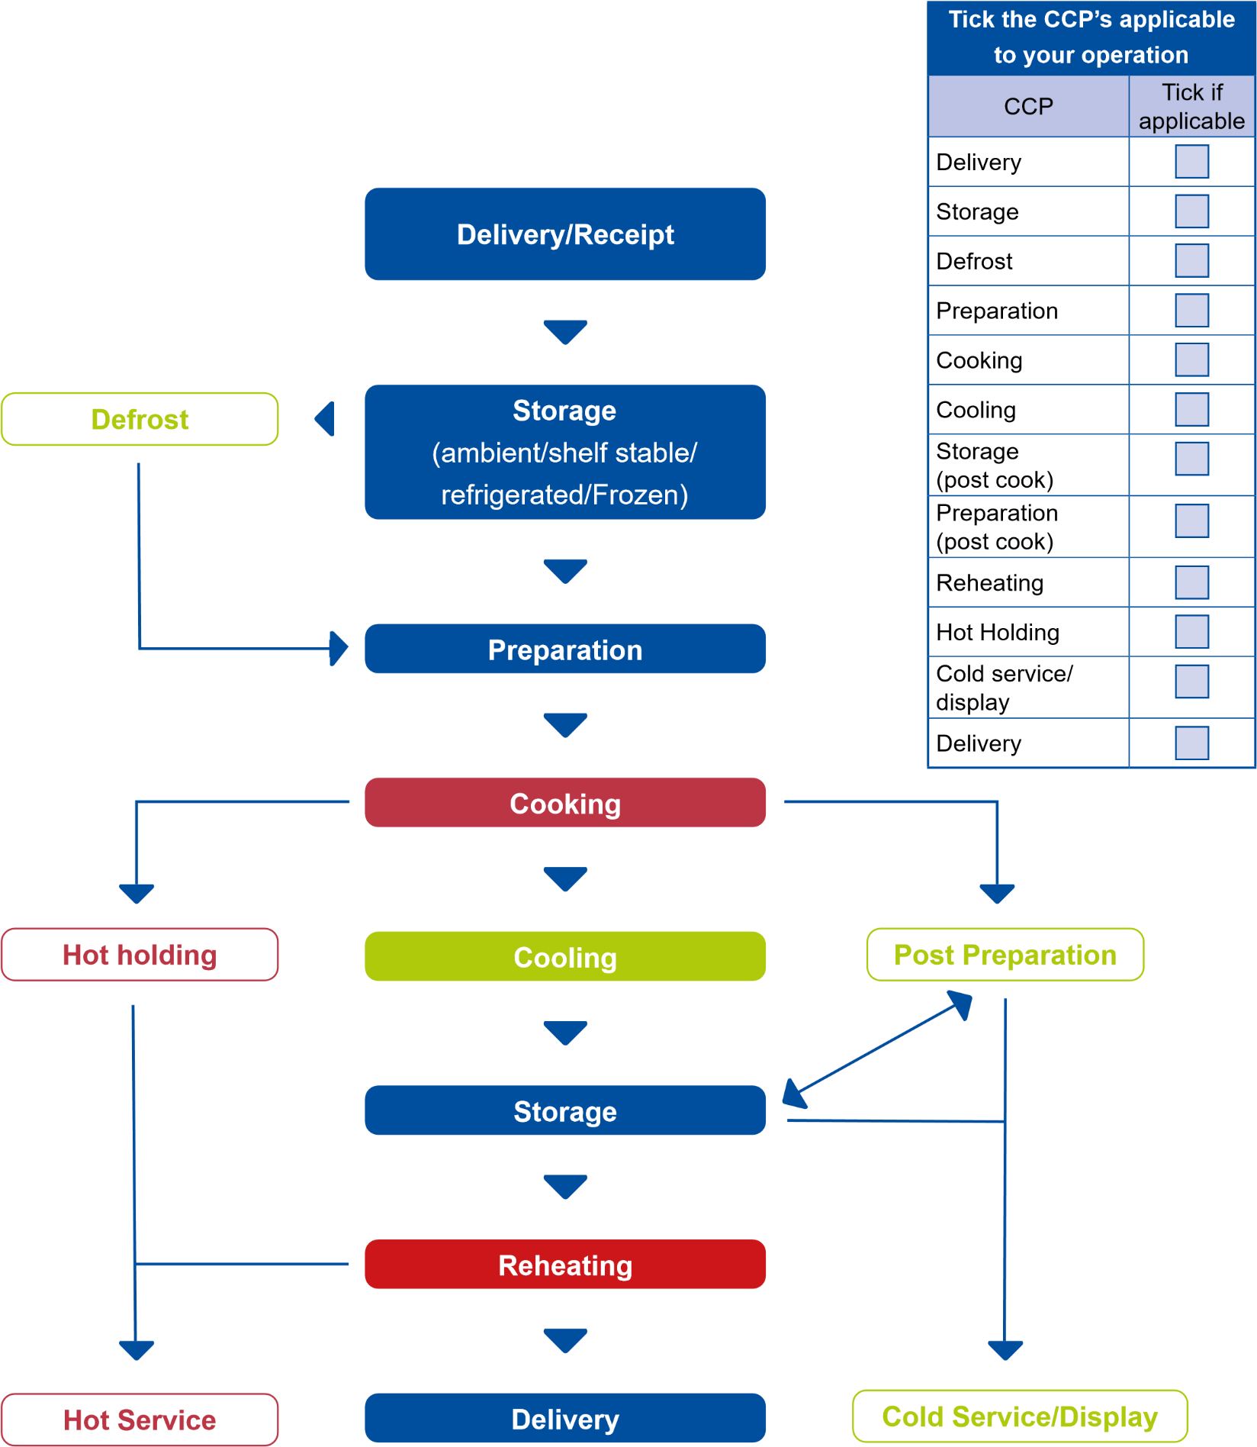
Flow Chart (Process Steps)

Description of Operations
Description of Operation  (Include the main stages: delivery, storage, preparation, handling/ processing/cooking, delivery)  Refer to process control chart. | Example: include in description how the food is handled, prepared and cooked. Whether food is cooked fresh and served immediately or foods held over to the following day/days. Describe any Butchery/ Deli Counters/Cook/Chill operations or any special processing i.e. vacuum packing, sous vide, sushi. marinating Shish. Include measures to prevent cross contamination i.e. separate chopping boards, dedicated fridges etc.
Description of foods handled | Examples include the handing of high-risk products i.e. meats, donor kebabs, burgers produced in house, fish, live shellfish, dairy, rice, vacuum packed products
Supplier Assurance  List suppliers and describe any checks you carry out to ensure your suppliers are meeting legal obligations | For example, invoices are kept with supplier details on them/  Import Licences for all foods from the EU and any Health Certificates are kept if required.  Any supplier temperature information/temperature delivery records/ keeping vehicle temperature logs/dockets.
Staff qualifications and experience | For example, Level 2 or 3 Food Hygiene Training/HACCP or Allergen Training and any FSA Training.

Sketch Plan of Kitchen/s/Preparation Areas
A sketch/layout plan of the kitchen is a useful tool which can be inserted into the pack.
Plans should be labelled and include key equipment i.e. wash hand basins, sinks, prep tables, fridges, chilled/dry food storage, segregation of clean/dirty areas etc.
If you are new business or your business has changed its operating model i.e. expanded or included higher risk foods you are advised to share this with your local Environmental Health Dept.
You can create your own plan or draw one on the next page.

Sketch Plan of Kitchen/s/Preparation Areas

HACCP Control Chart (Key steps & control measures)
Step | Process Step | Hazards | Control Measures | Actions | Monitoring/Corrective actions
1 | Purchase &  Receipt | Microbiological growth  Physical contamination  Chemical contamination  Allergen contamination | Chilled temperatures. 0-8ºC.  Correct stock rotation and in house traceability labelling.  Supplier assurance.  High risk food temperatures including meats, dairy products, fish etc 0-5ºC.  Visual inspection of foods for evidence of foreign body contamination, damage to packaging. | CCP Y/N  List Actions Taken: | Supplier control, i.e routine checks on suppliers, supplier questionnaires/audits.  Check approval number from suppliers where necessary i.e for meat, fish, dairy products.  Quality Checks i.e. visual inspection and check pack integrity on arrival.  Temperature monitored where appropriate.  Corrective Actions:  Reject delivery if temperature abuse or damaged packaging or out of date.  Contact supplier to advise of issues.

Step | Process Step | Hazards | Control Measures | Actions | Monitoring/Corrective actions
2 | Storage (cold holding, frozen storage & dry goods) | Microbiological growth  Physical contamination  Chemical contamination  Allergen contamination | Ensure food is covered wrapped and labelled. Separation between raw/uncooked & RTE  foods. All food stored within it’s use by date.  Correct stock rotation and in house traceability labelling.  Ensure raw and high risk food (ready-to-eat) is stored separately.  Chilled storage temperatures.  0-5ºC.  Frozen storage -18 to -23°C.  Ambient Store 12°C-22°C.  Allow for defrost chill storage air temperature of up to 12ºC for no more than 30 minutes in a 4 hour period.  Storage containers clean and good condition. | CCP Y/N  List Actions Taken: | Keep ingredients off the floor, strict stock rotation.  Visual checks of stored products.  Temperatures recorded twice a day  Freezer temperature record  Chilled temperature record Above 8ºC use within 4 hours  Corrective Actions:  Discard or further process food not meeting requirements.  Where frozen food has defrosted it may be used/cooked on the same day.

Step |  | Process Step |  | Hazards |  | Control Measures |  | Actions |  | Monitoring/Corrective actions
3 |  | Defrosting |  | Microbiological growth  Physical contamination  Chemical contamination  Allergen contamination |  | Defrost in fridge/chiller.  Chilled storage temperatures 0-8ºC.  Separation between raw/ uncooked & RTE foods. Protect food from risk of contamination. |  | CCP Y/N  List Actions Taken: |  | Temperature Monitoring  Corrective Actions:  Discard or further processing of food not meeting requirements.
 | Step |  | Process Step |  | Hazards |  | Control Measures |  | Actions |  | Monitoring/Corrective actions
 | 4 |  | Preparation |  | Microbiological growth  Physical contamination  Chemical contamination  Allergen contamination |  | Separation of non RTE and RTE foods. (separate preparation areas/separate equipment).  Dedicated utensils and chopping boards use colour coded equipment and dedicated sanitiser bottles.  Restrict time high risk foods left at room temperature (max 45 mins).  Thoroughly wash fruit, vegetables and salad items.  Follow E.coli 0157 guidance to prevent risk of contamination.  Cleaning between operations using approved sanitisers (2 stage clean using detergent then sanitiser).  Observe manufacturers  instructions, including dilution rates & contact times. |  | CCP Y/N  List Actions Taken: |  | Visual monitoring of staff practices during preparation, personal hygiene.  Cleanliness of equipment, worktops, utensils etc.  Corrective Actions:  Discard or further process food that does not meet the requirement.

Step | Process Step | Hazards | Control Measures | Actions | Monitoring/Corrective actions
5 | Cooking | Microbiological growth  Physical contamination  Chemical contamination  Allergen contamination | Products must achieve a core temperature of 75˚C  Temperature monitoring with calibrated and sanitised probe thermometer. Probe inserted into core of food & temperatures recorded.  Correctly sanitised equipment used throughout production. Use separate dedicated probe thermometers where possible.  Probe thermometers sanitised before use.  Regular maintenance checks on all cooking equipment & ensure correctly calibrated.  Prior use of cooking oils - ensure no risk of allergen contamination.  Consideration of acrylamide risks (extended cooking time at high temperatures). | CCP Y/N  List Actions Taken: | Record cooking temperatures (one product from each batch or random throughout the day).  Cooking log sheet to be used to record times and core temperatures.  Corrective Actions:  Any food that has not reached 75 °C should be cooked further until it reaches the required temperature.  Where there is a risk of allergen contamination the contaminated products must be suitably labelled with updated ingredients.

Step | Process Step | Hazards | Control Measures |  |  | Actions |  | Monitoring/Corrective actions
6 | Cooling | Microbiological growth  Physical contamination  Chemical contamination  Allergen contamination | Temperature monitoring with calibrated and sanitised probe thermometer. Probe is inserted into core using a long probe to record temperatures and recorded on the cooking and cooling log sheet.  Cool in small portions at room temperature or alternatively rapid cooling from cooking temperature to ambient temperature.  If blast chillers used these may be fitted with automatic alarms which will signal when product has been cooled to the target temperature.  Clean environment and food protected from risk of contamination.  All food products to be cooled to room temperature within 90 minutes & stored in a fridge. Place under refrigeration as soon as possible.  Visual checks. |  |  | CCP Y/N  List Actions Taken: |  | Cooling log sheet to be used to record times and core temperatures.  Corrective Actions: Dispose of any food has been left out of appropriate temperature control for too long.
Step | Process Step | Hazards |  | Control Measures | Actions |  | Monitoring/Corrective actions
7 | Chilled storage | Microbiological growth  Physical contamination  Chemical contamination  Allergen contamination |  | Chilled storage temperatures.  0-5ºC.  Correct stock rotation and in house traceability labelling.  Ambient Store 12°C-22°C.  Protect food from risk of contamination during storage. | CCP Y/N  List Actions Taken: |  | Keep ingredients off the floor, strict stock rotation.  Visual quality checks.  Temperature monitoring and recording.  Corrective Actions:  Dispose of any high-risk food that has been left too long at ambient temperatures.  Dispose of any food that may have been contaminated or gone out of date.

Step | Process Step | Hazards | Control Measures | Actions | Monitoring/Corrective actions
8 | Reheating | Microbiological growth  Physical contamination  Chemical contamination  Allergen contamination | Fully cook foods to 75˚C.  Protect food from risk of contamination. | CCP Y/N  List Actions Taken: | Corrective Actions:  Any food that has not reached 75ºC should be cooked further until it reaches the required temperature.

Step | Process Step | Hazards | Control Measures | Actions | Monitoring/Corrective actions
9 | Service | Microbiological growth  Physical contamination  Chemical contamination  Allergen contamination | Ensure allergen information is correct/reference to allergen matrix and orders under management control.  Consider screening/sneeze guards particularly where counters are buffet style or located near to customers.  Ensure no risk of contamination from the environment. Do not top up. Replace with cleaned receptacle and fresh food. Use of separate tongs.  Cold Display  Display high risk food at below 8°C and ideally below 5°C.  Where temperature control facilities are not available or cannot achieve target temperatures, apply a 2-hour rule (best practice) and in any case within 4 hours. Foods must be disposed of after this period. | CCP Y/N  List Actions Taken: | Record service temperatures during the display period.  Corrective Actions: Dispose of any food has been left out of appropriate temperature control for too long.  Dispose of any food that may have been contaminated.
Step 9 continued on the next page

Step | Process Step | Hazards | Control Measures | Actions | Monitoring/Corrective actions
9 | Service | Microbiological growth  Physical contamination  Chemical contamination  Allergen contamination | Hot Holding  Any hot held food for service must maintain a temperature of 63ºC or above.  Hot held foods falling below 63ºC during service must be disposed of after 2 hours or reheated and kept above 63ºC.  Preheat hot plates.  Stir food regularly.  Reference to allergen matrix | CCP Y/N  List Actions Taken: | Record service temperatures during the display period.  Corrective Actions: Dispose of any food has been left out of appropriate temperature control for too long.  Dispose of any food that may have been contaminated.

Step | Process Step | Hazards | Control Measures | Actions | Monitoring/Corrective actions
10 | Delivery to customer | Microbiological growth  Physical contamination  Chemical contamination  Allergen contamination | Refrigerated vehicle used to deliver food items if journey’s more than an hour. Correct stacking of packed product.  Use of cool boxes, ice packs.  Journeys within 1 hour otherwise refrigerated vehicles used. Ensure vehicles are clean.  Staff Training, Hygiene rules followed. | CCP Y/N  List Actions Taken: | Corrective Actions: Dispose of any food has been left out of appropriate temperature control for too long.  Dispose of any food that may have been contaminated.  Monitor and record delivery temperatures.

Information Sheets (Critical Control Points - CCP)

Purchase and Receipt

Storage (cold holding, frozen storage and dry goods)

Preparation

Cooking

Chilling

Storage (cold holding)

Post Preparation

Reheating

Service (including chilled/ambient holding/display)

Delivery

Purchase & Receipt

Hazards
- Presence of pathogens (bacteria, viruses and moulds) multiplication, toxin formation
- Physical contamination
- Chemical contamination
- Cross-contamination
- Presence of allergens
Controls | Monitoring/Corrective action
Temperature:  Chilled temperatures. 0-8ºC.  Correct stock rotation and in house traceability labelling.  Supplier assurance.  High risk food temperatures including meats, dairy products, fish etc. 0-5ºC.  Visual inspection of foods for evidence of foreign body contamination, damage to packaging. | Record temperatures on log sheet.  Supplier control, supplier audit. Ensure approved establishment numbers visible relating to any products of animal origin.  Quality Checks i.e. visual inspection and check pack integrity on arrival. Temperature monitored where appropriate.
Contamination:  Ensure separation of Non RTE and RTE foods on delivery. | Visual monitoring  Reject contaminated RTE foods
Allergen control:  Check allergen ingredients and cross reference with allergen matrix.  Keep products/ingredients containing allergens away from other products (stored in separate area, enclosed receptacles/lidded containers). | Visual monitoring to ensure no cross contamination between ingredients.  Where cross contamination has occurred (eg due to spillages etc) any contaminated ingredients to be re-labelled or discarded if they cannot be used safely.

Storage (Cold Holding, Frozen Storage And Dry Goods)

Hazards
- Presence of pathogens (bacteria, viruses and moulds) multiplication, toxin formation
- Physical contamination
- Chemical contamination
- Cross-contamination
- Presence of allergens
Controls | Monitoring/Corrective action
Temperature and Stock Control:  Correct stock rotation and in house traceability labelling.  Planned maintenance of chiller.  Allow for defrost chill storage air temperature of up to 12ºC for no more than 30 minutes in a 4 hour period.  Chilled storage temperatures. 0-5ºC.  Frozen storage -18 to -23°C.  Ambient Store 12°C- to 22°C.  Food grade chemicals used to clean units. | Quality checks. Chilled food temperatures recorded twice a day on Chilled temperature record.  Above 8ºC use within 4 hours or discard.  Temperature monitoring and recording (see chiller and freezer record sheet).  Where cleaning deficiencies noted – areas to be re-cleaned and disinfected where necessary.  Cover food and label foods with use by /discard dates.

Controls | Monitoring/Corrective action
Contamination:  Raw and ready-to -eat foods should be stored in separate fridges or with effective segregation.  Placed away from environmental sources of contamination.  Keep ingredients off the floor, strict stock rotation. | Visual monitoring.  Where Ready-to-eat foods have been contaminated they will be either re-processed or discarded.  Defrosting should be carried out under controlled conditions such as in a fridge/chiller. It must not be carried out at ambient temperature or in hot water.
Allergen control:  Check allergen ingredients and cross-reference with allergen matrix.  Allergen ingredients segregated from other foods. Placed in dedicated area.  Cleanliness of equipment/receptacles in contact with food. | Visual monitoring.  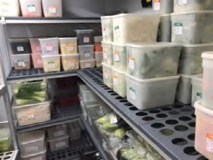  Where cross contamination has occurred (eg due to spillages etc) any contaminated ingredients to be re-labelled or discarded if they cannot be used safely.

Preparation

Hazards
- Presence of pathogens (bacteria, viruses and moulds) multiplication, toxin formation
- Physical contamination
- Chemical contamination
- Cross-contamination
- Presence of allergens
Controls | Monitoring/Corrective action
Temperature and Stock Control:  Preparation should be completed as quickly as possible and in any case aim to restrict time, high risk foods are left at ambient temperature during preparation (i.e max 45 mins). | After 1 hours use or dispose of food.
Contamination:  Separation of non RTE and RTE foods Separate preparation areas/separate equipment.  Consider separate raw meat section.  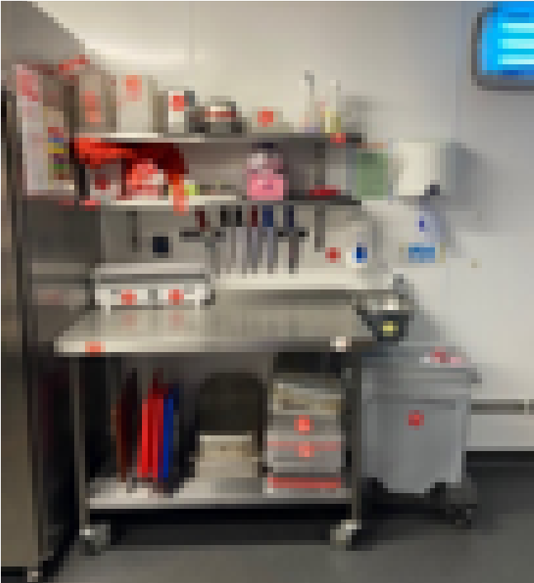  Dedicated utensils and chopping boards  (coloured equipment)  Thoroughly wash fruit, vegetables and salad items. Use of colander.  Thoroughly clean and disinfect sinks and adjoining areas before and after operations. | Visual monitoring of staff practices during preparation, personal hygiene.  Visual monitoring regarding cleanliness of equipment, worktops, utensils.  Any contaminated food disposed or safely reprocessed.  Ensuring separate areas/equipment  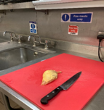

Controls | Monitoring/Corrective action
Follow Cross Contamination guidance to prevent risk of contamination.  Cleaning before and between operations using approved sanitisers (2 stage clean using detergent then sanitiser).  Glass policy.  Cleaning schedules. E.coli policy.  Sanitiser BS 1276/13697  Adequate supplies of sanitiser BS 1276/13697  Dedicated aprons, cleaning cloths, disinfectant/ sanitiser spray bottles, vacuum packers, mixer/ mincer etc. | 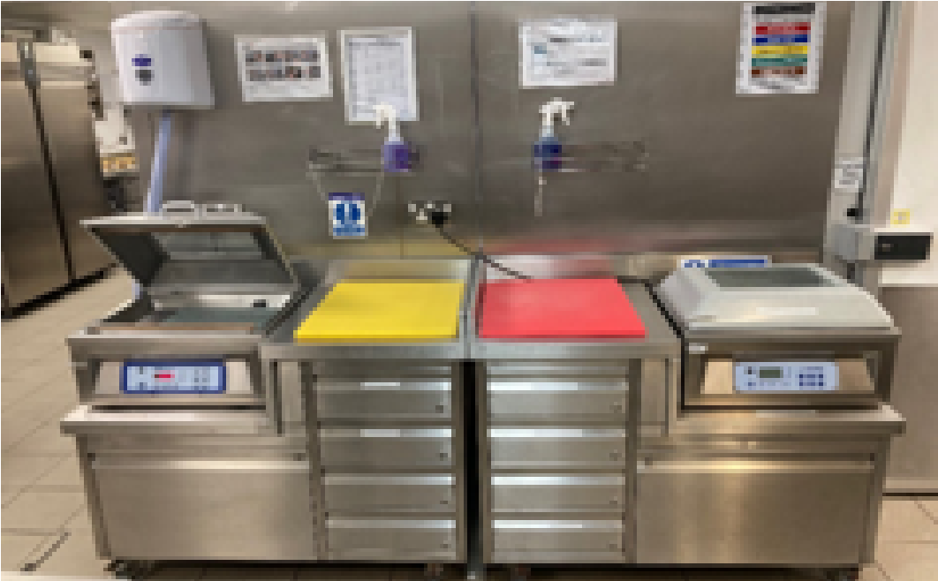  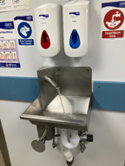  Regular washing hands
Allergen control:  Ensure allergen information is correct/ reference to allergen matrix and orders under management control.  Allergen ingredients segregated from other foods. Preparation of food in dedicated area. Area cleared- equipment and surfaces cleaned beforehand.  Food protected from risk of contamination and not prepared in the vicinity of allergen ingredients.  Cleanliness of equipment in contact with food.  If it is not possible to guarantee control of cross contamination, do not offer allergen free foods to customers. | Visual monitoring.  Where cross contamination has occurred (eg due to spillages etc) any contaminated ingredients to be re-labelled or discarded if they cannot be used safely.  Keep foods with allergens separate in dedicated containers  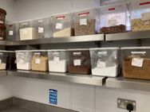

Cooking

Hazards
- Presence of pathogens (bacteria, viruses and moulds) multiplication, toxin formation
- Physical contamination
- Chemical contamination
- Cross-contamination
- Presence of allergens
Controls | Monitoring/Corrective action
Temperature:  Products must achieve a target temperature of 75˚C.  Temperature monitoring with calibrated, sanitised probe thermometer into core of food and temperature recorded.  Ideally cooked food / finished product kept in separate area from non-RTE items.  Correctly sanitised tools and equipment used throughout production.  Preheat any ovens and check programme controls.  Regular maintenance checks on all cooking equipment /monitoring controls.  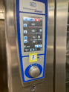 | Record temperatures on form /log sheet.  Daily records signed off by supervisor/kitchen manager/head chef.  Temperature probes sanitised before use.  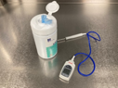  Cook until target temperature achieved.  Any food that has not reached 75 °C should be cooked further until it reaches the required temperature.  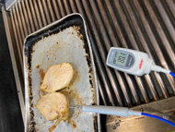

Controls | Monitoring/Corrective action
Staff training.  Check all equipment and tools, gloves for damage before and during use.  Regular maintenance checks on all equipment.  Consideration of acrylamide risks (extended cooking time at high temperatures). | Level 2 training minimum for staff and level 3 for managers /supervisors/FBO.  Keep records of equipment checks, defects and remedial action.
Contamination:  Separate utensils & designated areas for raw & cooked/RTE product.  Colour coded equipment including chopping boards.  Separate spatulas/tongs for raw/cooked foods  i.e burgers, chicken etc. | Any contaminated food disposed or safely reprocessed.
Allergen control:  Upon notification of allergen free meal clear/ clean surface, use newly cleaned equipment and/or dedicated equipment.  Wash hands before and after handling food.  Keep allergens away from cooked finished product (stored in separate area, enclosed receptacles/lidded containers).  Cleanliness of cooking equipment, ovens, griddles, pans etc.  Use of separate/dedicated equipment i.e spatulas. | Visual monitoring.  Where cross contamination has occurred (eg due to spillages etc) any contaminated ingredients to be re-labelled or discarded if they cannot be used safely.

Cooling

Hazards
- Presence of pathogens (bacteria, viruses and moulds) multiplication, toxin formation
- Physical contamination
- Chemical contamination
- Cross-contamination
- Presence of allergens
Controls | Monitoring/Corrective action
Temperature:  Products to be cooled to room temperature within 90 minutes & placed in a fridge immediately.  Visual checks.  Probe inserted into core of food & record temperatures recorded on the cooking and cooling log sheet.  Cool in small portions at room temperature or alternatively rapid cooling from cooking temperature to ambient temperature.  Clean environment. No open windows unless fly screens in place.  If blast chillers used these may be fitted with automatic alarms which will signal when product has been cooled to the target temperature. | Record cooling temperatures on temperature log.  If not cooled correctly dispose of food unless it can be reprocessed safely i.e reheated or consumed immediately.
Contamination:  Store in location free from risk of contamination.  After cooling ensure food is covered and labelled with a use by date. | Any contaminated food disposed or safely reprocessed.

Controls | Monitoring/Corrective action
Allergen control:  Allergen ingredients are segregated from other foods. Cooling of food in dedicated area.  Area cleared- equipment and surfaces cleaned beforehand.  Food protected from risk of contamination and not cooled in the vicinity of allergen ingredients.  Cleanliness of equipment/receptacles in contact with food. | Visual monitoring.  Where cross contamination has occurred (eg due to spillages etc) any contaminated ingredients to be re-labelled or discarded if they cannot be used safely.

Storage (Cold Holding)

Hazards
- Presence of pathogens (bacteria, viruses and moulds) multiplication, toxin formation
- Physical contamination
- Chemical contamination
- Cross-contamination
- Presence of allergens
Controls | Monitoring/Corrective action
Correct stock rotation and in house traceability labelling.  Planned Maintenance of chiller.  Allow for defrost chill storage air temperature of up to 12ºC for no more than 30 minutes in a 4 hour period.  Chilled storage temperatures. 0-5ºC.  Food grade chemicals used to clean units. | Quality checks.  Chilled food temperatures recorded twice a day on chilled temperature record.  Temperature monitoring and recording (see chiller and freezer record sheet)  Record discarded produce on recording sheet.
Contamination:  Raw and ready-to-eat foods stored in separate refrigerators or effectively segregated.  Placed away from environmental sources of contamination.  Keep stored food off floor. | Visual monitoring.

Controls | Monitoring/Corrective action
Allergen control:  Check allergen ingredients and cross-reference with allergen matrix.  Allergen ingredients segregated from other foods or placed in dedicated area.  Cleanliness of equipment/receptacles in contact with food. | Visual monitoring.  Where cross contamination has occurred (eg due to spillages etc) any contaminated ingredients to be re-labelled or discarded if they cannot be used safely.

Post Preparation (Further Preparation After Cooking)

Hazards
- Presence of pathogens (bacteria, viruses and moulds) multiplication, toxin formation
- Physical contamination
- Chemical contamination
- Cross-contamination
- Presence of allergens
Controls | Monitoring/Corrective action
Temperature:  Preparation should be completed as quickly as possible and in any case aim to restrict time high risk foods are left at ambient temperature during preparation (i.e max 45 mins). | After 1 hours use or dispose of food.
Contamination:  Separation of non RTE and RTE foods. (separate preparation areas/separate equipment).  Dedicated utensils and chopping boards used (coloured equipment).  Thoroughly wash fruit, vegetables and salad items.  Follow Cross Contamination guidance to prevent risk of contamination.  Cleaning before and between operations using approved sanitisers (2 stage clean using detergent then sanitiser).  Glass policy.  Cleaning schedules. E.coli policy.  Sanitiser BS 1276 / 13697. | Visual monitoring of staff practices during preparation, personal hygiene.  Visual monitoring re cleanliness of equipment, worktops, utensils.  Any contaminated food disposed or safely reprocessed.

Controls | Monitoring/Corrective action
Allergen control:  Ensure allergen information is correct/ reference to allergen matrix and orders under management control.  Allergen ingredients segregated from other foods. Preparation of food in dedicated area. Area cleared- equipment and surfaces cleaned beforehand.  Food protected from risk of contamination and not prepared in the vicinity of allergen ingredients.  Cleanliness of equipment in contact with food. | Visual monitoring.  Where cross contamination has occurred (eg due to spillages etc) any contaminated ingredients to be re-labelled or discarded if they cannot be used safely.

Reheating

Hazards
- Presence of pathogens (bacteria, viruses and moulds) multiplication, toxin formation
- Physical contamination
- Chemical contamination
- Cross-contamination
- Presence of allergens

Controls | Monitoring/Corrective action
Temperature:  Products must achieve a target temperature of 75˚C.  Temperature monitoring with calibrated and sanitised probe thermometer. Probe is inserted into core.  Cleaning Schedules followed. Personal hygiene rules followed  Staff training, wash hands.  Check all equipment and tools, gloves for damage before and during use.  Regular maintenance checks on all equipment. | Record temperatures on log sheet.  Reheat until specified temperature achieved.
Contamination:  Keep away from potential sources of contamination. | Visual monitoring.  Any contaminated food to be safely reprocessed or disposed of.
Allergen control:  Allergen ingredients segregated from other foods. Placed in dedicated area.  Cleanliness of equipment/receptacles in contact with food. | Visual monitoring.  Where cross contamination has occurred (eg due to spillages etc) any contaminated ingredients to be re-labelled or discarded if they cannot be used safely.

Service (Including Chilled/Ambient Holding/Display, Hot Holding.)

Hazards
- Presence of pathogens (bacteria, viruses and moulds) multiplication, toxin formation
- Physical contamination
- Chemical contamination
- Cross-contamination
- Presence of allergens
Controls | Monitoring/Corrective action
Temperature:  Chilled products to be held 8°C or below.  If this cannot be achieved then hold for two hours then discard.  High risk food kept below 8°C.  Where temperature control facilities are not available or cannot achieve target temperatures, apply a 2-hour rule (best practice) and in any case within 4 hours. Foods must be disposed of after this period.  Hot Holding:  Any hot held food for service must maintain a temperature of 63°C or above.  Hot held foods falling below 63°C during service must be disposed of after 2 hours.  Preheat hot plates.  Stir food regularly.  Do not top up. Replenish with clean container of fresh food. | Record temperatures on form.  2 hour rule monitored and recorded where equipment does not maintain product below 8°C.  Dispose of product not maintaining specified temperatures.  Hot food must be kept at 63°C or above, except for certain exceptions. If it is not possible i.e hot holding equipment is not available or is not capable of keeping food above this temperature then the food can be held below 63°C but only for a maximum of two hours, but this can only be done once.

Controls | Monitoring/Corrective action
Contamination:  Store in location free from risk of contamination.  Food protected where possible. Consider screening/sneeze guards particularly where counters are buffet style or located near to customers.  Clean equipment. | Visual monitoring.  Any contaminated food to be safely reprocessed or disposed of.
Allergen control:  Ensure allergen information is correct/ reference to allergen matrix and orders under management control.  Allergen ingredients segregated from other foods.  Food protected from risk of contamination.  Final check on allergens before serving-if necessary consult allergen matrix.  Cleanliness of equipment in contact with food.  Designated tongs replaced on a regular basis.  Allergen labelling for foods pre packed for direct sale ( PPDS). | Visual monitoring.  Where cross contamination has occurred (eg due to spillages etc) any contaminated ingredients to be re-labelled or discarded if they cannot be used safely.

Delivery

Hazards
- Presence of pathogens (bacteria, viruses and moulds) multiplication, toxin formation
- Physical contamination
- Chemical contamination
- Cross-contamination
- Presence of allergens

Controls | Monitoring/Corrective action
Temperature:  High risk food should be kept below 8ºC.  Refrigerated vehicle used to deliver food items if journeys more than an hour otherwise use cool boxes/ice packs.  Refrigerated vehicle temperatures below 8ºC.  Hot deliveries kept above 63ºC. | Carry out temperature checks for journeys over 1 hour.
Contamination:  Non RTE and RTE foods are stored in separate refrigerators or with effective segregation.  Correct stacking of packed product.  Visual inspection of vehicle.  Cleaning Schedule for despatch vehicle followed.  Planned Maintenance of vehicles.  Company Hygiene and housekeeping Policy/ Cleaning Schedule followed/Pest Control/ Site glass and brittle material policies.  Food grade chemicals used in vehicle only Vehicle has no strong taints or odours. | Visual monitoring.  Keep foods off the floor, strict stock rotation.

Controls | Monitoring/Corrective action
Allergen control:  Check allergen ingredients and cross-reference with allergen matrix.  Allergen ingredients segregated from other foods.  Allergen labelling required (Food delivery platforms, takeaway deliveries & customer collections). | Visual monitoring.  Where cross contamination has occurred (eg due to spillages etc) any contaminated ingredients to be re-labelled or discarded if they cannot be used safely.

Food Safety Pre-Requisites
(Basic safety/hygiene requirements)

Prerequisite | Requirements & Action Taken
Suitability of premises and provision of services.  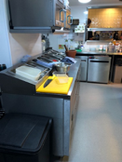 | Premises is ‘fit for purpose’, has sufficient space to carry out operations, the layout supports safe practices, surfaces are impervious and able to be effectively cleaned. Sufficient wash hand basins, sinks, preparation surfaces. (Plan of premises). Sufficient ventilation (natural or mechanical) with flow from clean to dirty zones. Effective pest proofing measures in place.  The structure including floors and walls should be smooth , impervious and readily cleansable. Preparation tables/counters ideally made of stainless steel or a hardwearing food grade laminate.  Sufficient lighting to enable hygienic operations.  Supply of potable water and suitable drainage.
Details of Action Taken

Prerequisite | Requirements & Action Taken
Wash hand basins (WHB) | Suitable number of wash hand basins should be installed with at least one in the food preparation area. The basin or sink must have hot and cold water (or mixed at a suitable temperature) and soap (preferably liquid or spray soap). You need to provide something to dry hands with, ideally paper towels, which are used once and then thrown away. In larger kitchens where there are more complex operations there should be dedicated WHB’s in each area i.e Butchery, raw veg prep, RTE prep .  Toilets should have their own dedicated WHB(s).  WHB(s) should be non-hand operated.
Details of Action Taken

Prerequisite | Requirements & Action Taken
Washing food and equipment | Ideally use a dishwasher. Do not overload the dishwasher and make sure it is maintained and serviced regularly.  If you do not have a dishwasher, wash plates, equipment, etc, in hot soapy water using detergent and rinse.  Separate sinks should be used for washing equipment.  There should be dedicated sinks for washing food (use a colander wash salads).  If you have to use the same sink for all activities, the water must be changed and the sink (including all taps/fittings) must be thoroughly cleaned and disinfected using a two stage clean between uses.  Rinse thoroughly after washing with hot water to remove detergent.  Ensure you wash anything contaminated with raw meat/soil separately.  Anything contaminated with raw meat, soil etc including containers, equipment, chopping boards must be washed separately and disinfected. Contaminated work surfaces and hand contact points such as fridge door handles must also be cleaned and disinfected.
Details of Action Taken

Prerequisite | Requirements & Action Taken
Personal Hygiene   | To keep food safe, every person working in a food-handling area must maintain a high level of personal hygiene.  They must wear clothing that is:  - suitable  - clean  - protective  When preparing or handling food they should:  - keep hair tied back and wear a suitable head covering, e.g. hat or hair net  - not wear watches or jewellery (except a wedding band)  - not touch their face and hair, smoke, spit, sneeze, eat or chew gum.  Handwashing  Effective handwashing is extremely important to help prevent harmful bacteria from spreading from peoples’ hands. All staff that work with food must wash their hands:  - when in the kitchen or preparation area  - before preparing food  - after touching raw food  - after handling food waste or emptying a bin  - after cleaning  - after blowing their nose  - after touching phones, light switches, door handles and cash registers  Staff should dry their hands on a disposable towel. This is because harmful bacteria can spread on wet or damp hands. Use a disposable towel to turn off the tap.
Details of Action Taken

Prerequisite | Requirements & Action Taken
Equipment suitability | The surfaces of equipment in contact with food should be smooth, impervious and readily cleansable. The equipment facilitates cleaning, disinfection and maintenance. Food contact surfaces do not affect or affected by the cleaning system.  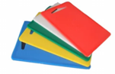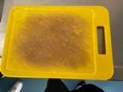
Details of Action Taken
Calibration | Equipment used for measuring and monitoring i.e. temperature probes sufficiently accurate and reliable to provide confidence in results.
Details of Action Taken
Stores/Warehousing | Storage facilities for raw materials, including packaging, in-process product, and finished products is fit for purpose and do not pose any contamination risk.
Details of Action Taken
Pest Control  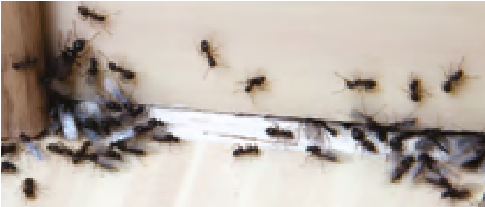 | Pest control programme in place to minimise risk of infestation. Effective pest proofing. Daily checks / appropriate treatments in place. Consider preventative pest control contract.  Effective cleaning and hygiene practices. Staff trained to identify pest activity.
Details of Action Taken

Prerequisite | Requirements & Action Taken
Control of Refuse | Ensure food waste and other refuse is effectively disposed of. Lids closed and bins regularly emptied. Waste transfer notes kept on site details of Action Taken  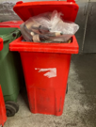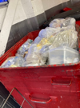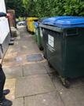
Details of Action Taken
Preventative maintenance | Maintenance programmes in place for plant / equipment especially critical equipment (fridges, freezers, cooking equipment), essential services such as gas, electricity and water. Activities prevent contamination and reduce potential for breakdowns.
Details of Action Taken

Prerequisite | Requirements & Action Taken
Contract services (i.e.  waste/laundry) | Contract services meet the requirements of business, prevent contamination of products or production areas.
Details of Action Taken
Glass and plastic management | Glass / brittle materials excluded where possible. Where they are present action taken to protect against breakage.
Details of Action Taken
Distribution | Vehicles / containers used to transport products do not present a risk to the safety / quality of the products. Vehicles clean. NonRTE and RTE foods separated. Ensure food is held at the correct temperature and/or journeys time limited.
Details of Action Taken
Measures to prevent cross-contamination | Systems in place to prevent, control and detect contamination (i.e. physical, chemical, allergen and microbiological). Colour coded equipment, dedicated equipment, separate areas for raw and RTE food.  Hand Washing before and during handling and preparation of foods.  Bought in items such as sauces, spices and menu items checked for allergenic ingredients.
Details of Action Taken
Cleaning and sanitising | Cleaning schedules in place, clean as you go policies implemented. Systems in place to monitor suitability and effectiveness of cleaning and sanitising. 2 stage cleaning to prevent E coli 0157 Risks, correct disinfectants / sanitisers used (BS EN 1276 and/or 13697). (COSHH risk assessments). Follow manufacturer’s instructions.
Details of Action Taken
Supplier assurance | All suppliers identified (including those for packaging) and checked to ensure they supply safe food.
Details of Action Taken

Prerequisite | Requirements & Action Taken
Receipt | Packaging fit for purpose, storage of packaging should be considered to lower the risk of contamination and deterioration.  Correct labelling (use by dates, ingredients & allergens).  Ensure temperature control of high risk foods.
Details of Action Taken
Traceability | Systems in place to trace all raw material product lots (including packaging) from the supplier through all stages of processing and despatch to the customer and the reverse (i.e. traceability from the customer back to the suppliers of the raw materials).
Details of Action Taken
Product recall and withdrawal | System in place to identify, locate and withdraw unsafe food from the market/customer.
Details of Action Taken
Personnel hygiene and employee facilities | Good hygiene practices followed. Staff understand the risk of cross contamination to food products and take appropriate actions to minimise risk. All personnel, visitors and contractors comply with personal hygiene requirements.
Details of Action Taken
Return to work after illness | Action taken to minimise the risk of product becoming contaminated by personnel returning to work. No return to work until 48 hours after last symptoms or until medical exclusion complete/clearance received.
Details of Action Taken
Training | Food handlers and managers competent for their role. Evidence of this demonstrable through training, work experience or qualification i.e. Level 2 Food Safety (Level 3 for Managers & Supervisors). Allergen training to be included.
Details of Action Taken

Prerequisite | Requirements & Action Taken
Standard Operating  Procedures (SOPs) | Operate to documented procedures / instructions ensuring production of consistently safe food in compliance with the HACCP. See guidance for vacuum packing, Sushi, low temperature cooking, allergens at the end of the pack.
Details of Action Taken
Document control | System in place to ensure that only the most recent versions of documents and forms are available and in use. Food safety management system reviewed on a regular basis and when there are any changes to the operation.
Details of Action Taken
Customer complaints | Customer complaints effectively addressed and analysed.  Information gathered used to identify cause of complaint to enable cause to be remedied.
Details of Action Taken
Product information/ consumer awareness | Information presented to consumers in accordance with the Food Information Regulations and HACCP requirements.
Details of Action Taken

Record Sheets
The ‘All in one record’ at the back of this section covers the majority of critical checks for smaller operations but businesses that are more complex may wish to use the more detailed recording forms.
The level of detail required when completing sections will be dependent on the size of the business and the food safety risks.
It is a legal requirement to demonstrate that critical controls relevant to your business are being monitored. These ‘prove it’ records contained within this section give enhanced assurance that checks are being carried out.
The ‘Record Keeping Section’ contains various forms which, when completed, will help the business to demonstrate that critical checks are being carried out.
Example Record Sheets:
- Delivery Record
- Cold Food Record
- Hot Temperature Record
- Allergen Matrix
- Allergen Management House Rules
- All in one Record

Delivery Record
Decide how many food items you will probe or check per delivery.
Best before date | Temp | Corrective Action |  | Initials
Have the corrective actions been carried out? |  |  | Date checked by Manager/Supervisor |  | Initials
Yes / No / Not Applicable
(delete as applicable)
Please note:
High risk chilled food delivered below 8°C (ideally 5°C or below)
All food protected from risk of contamination.

Cold Food Record
Temperature of Refrigerator Chill/Cold  - RECOMMENDED TWICE PER DAY  Function/Temperature of Freezer  - RECOMMENDED ONCE PER DAY |  |  |  |  |  |  |  |  |  |  | Month:
UNIT
DATE
1st
2nd
3rd
4th
5th
6th
7th
8th
9th
10th
11th
12th
13th
14th
15th
16th
17th
18th
19th
20th
21st
22nd
23rd
24th
25th
26th
27th
28th
29th
30th
31st

Write your Critical Limits here:
 | Critical Limit | Notes | Corrective Action Examples:
Refrigerator(s) |  |  | Recheck temperature  Consider if food is safe to use.  Dispose of food which may be contaminated.  Review staff training  Call the engineer
Chill(s)
Cold Display(s)
Freezer(s)
Have the corrective actions been carried out? |  | Date checked by Manager/Supervisor: |  | Initials
Yes / No / Not Applicable
(delete as applicable)
Fridges below 5°C (legal limit below 8°C). Take corrective action if above critical temperatures.
Freezers -18°C

Hot Temperature Food Record
Decide which food items you check per day. NB Foods cooked to a core temperature of 75°C/Cooled within 90 minutes
 |  |  | COOKING |  | COOLING |  | REHEATING | CORRECTIVE ACTION
Date | Food Items Core | Time  Started  Cooking | Time  Finished  Cooking | Core Temp | Time  Started  Cooling | Time  Finished  Cooling | Core Temperature | Action Taken | Initials
Page 51
Write your Critical Limits here:
 | Critical Limit | Notes | Corrective Action Examples:
Cooking |  |  | Continue cooking until your specified temperature is achieved.  Consider if food is safe to use/dispose of food which may be contaminated.
Cooling |  |  | Consider if food is safe to use/dispose of food which may be contaminated.  Revise cooling procedure/review staff training.
Reheating |  |  | Continue reheating until your specified temperature is achieved.  Review staff training.
Have the corrective actions been carried out? |  | Date checked by Manager/Supervisor |  | Initials
Yes / No / Not Applicable
(delete as applicable)

e 52

Allergen Matrix
Write a list of the food used in your business which contains these allergens.
Dishes |  |  |  |  |  | 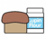 | 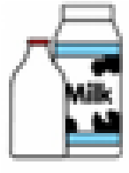 |  |  |  |  |  |  | 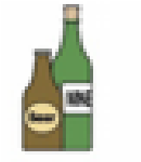
 | Celery | Cereals containing  gluten* | Crustaceans | Eggs | Fish | Lupin | Milk | Mollusc | Mustard | Nuts† | Peanuts | Sesame seeds | Soya | Sulphur Dioxide
Tuna Salad [example]

Dishes and their allergen content (Note – Please state the name of the cereal(s) containing gluten* and/or the name of the nut(s)†)
Review date: Reviewed by:
You can find this template, including more information at www.food.gov.uk/allergy-guidance

Allergen Management House Rules
Enter a statement of your Allergen Management House Rules in the table below:
Describe your Control Measures and Critical Limits and the Monitoring including frequency
Deliveries and labels
Storage
Preparing dishes
Staff Training
Communicating with your customers
What to do in the event of an emergency
Monitoring/checking and any other appropriate records used by your business | • Weekly Record
Name: (Print) | Signature: | Job Title: | Date
The Allergen Management House Rules are an essential component of your HACCP based system and must be kept up to date at all times.

All-In-One Record
To be completed daily and used as an alternative to the individual records: ‘Delivery Record’, ‘Cold Food Record’, Hot Temperature Record’, ‘Hot Holding Record’ and ‘Off Site Temperature Record’
DELIVERIES – You decide how many food items should be probed in each delivery
Supplier’s name
Details of food items
Van condition
- Cleanliness
- Separation of Raw and Cooked / Ready-to-eat food
Food temperature
- Critical Limit - Chilled: ………
- Critical Limit – Frozen: ………
Food condition
• Packaging/Contamination
Within date codes
• ‘Use-by’ or ‘Best-before’
Corrective Actions
- Reject Food
- Review supplier
- Review staff training

COLD FOOD RECORD
Refrigerators/Chill/Cold Display  • Critical Limit |  | Unit |  |  | Unit |  |  | Unit |  |  |  | Unit
Temperature checks  (Recommended twice daily) |  | AM | PM |  | AM |  | PM | AM |  | PM |  | AM | PM
Freezers  • Critical Limit |  | Unit |  |  | Unit |  |  | Unit |  |  |  | Unit
Function checks
(Recommended once daily)
Corrective Actions
- Recheck Temperature
- Move food to alternative and suitable chilled storage
- Consider if food safe to use or discard
- Review staff training
HOT TEMPERATURE RECORD – NB Foods cooked to a core temperature of 75oC/Cooled within 90 minutes
Write Your Critical Limit for Cooking here:
Write Your Critical Limit for Cooling here:
Write Your Critical Limit for Reheating here:
Food Item | COOKING |  |  |  |  | COOLING |  |  |  |  | REHEATING
Food Item | Time  Started  Cooking | Time  Finished  Cooking |  | Core Temp |  | Time  Started  Cooling |  |  | Time  Finished  Cooling |  | Core Temperature

Corrective Actions:  Cooking:  - Continue cooking until 75oC is achieved  - Consider if food is safe to use/dispose of food which may be contaminated  Cooling:  - Consider if food is safe to use/dispose of food which may be contaminated  - Revise cooling procedure/review staff training Reheating  - Review staff training | Notes:
HOT HOLDING RECORD AND/OR OFF SITE TEMPERATURE RECORD
You determine the monitoring frequency in your Temperature Control House Rules
Write Your Critical Limit for Hot Holding and/or Off Site Temperatures:
Food Item |  | Core Temp | Time of Check
Corrective Actions:  • Consider if food is safe to use | Notes:
Manager/Proprietor’s Signature: | Date

Standard Operating Procedures (SOP’s)

10.1 Allergens Guide
10.2 Preventing cross-contamination
10.3 Procedure for Safe Production of Sushi and Sushimi
10.4 Vacuum packaging Guide
10.5 Cake Makers Guidance
10.6 Burger Cooking Guide

Allergens SOP
Food Allergens
What is a food allergy?
Food allergy is a reaction caused when the body’s immune system reacts unusually to components in foods, usually specific proteins. Symptoms include tingling in the mouth, itchy skin rash, swelling of the face or mouth, shortness of breath, nausea, abdominal pain and diarrhoea. Some people may develop anaphylaxis which may lead to a severe or even life-threatening reaction, where symptoms may additionally include vomiting, breathing difficulties and a dramatic fall in blood pressure leading to unconsciousness and even death.

The14 Food Allergens
In the UK, food businesses must inform customers under food law if they use any of the 14 allergens as ingredients in the food and drink they provide. This includes brought in condiments/sauces etc.
Celery | This includes celery stalks, leaves, spice and celery salt. It is often found in salads, some meat products, soups and stock cubes. People with a celery allergy also need to avoid celeriac, as they are varieties of the same species.
Cereals containing gluten | Gluten is the name of a family of proteins found in wheat, barley, rye and oats. It is often found in foods containing flour and therefore bread, baked goods, cereals and pasta. It can also be found in barley based products such as beer, malt, malt vinegar and food colouring.
Crustaceans | These include crabs, lobsters, prawns, crabs and scampi. They are often found in shrimp paste used for curries.
Eggs | These are often found in cakes, some meat products, mayonnaise, mousses, pasta, quiche and food brushed with egg.
Fish | Often found in fish sauces, pizzas, relishes, salad dressings and stock cubes. Fish and shellfish allergies are one of the most common allergies in adults, and can develop at any point in life with no previous symptoms experienced when eating fish.
Lupin | This includes lupin seeds and flour and can be found in some types of bread, pastries and pasta.
Milk | This is found in butter, cheese, cream, milk powders, yoghurt and foods glazed with milk. Milk and milk powder can be used as coatings i.e on chicken and chips.
Molluscs | These include mussels, land snails, squid and whelks. They are often found in oyster sauce or as an ingredient in fish stews.
Mustard | This includes mustard powder, liquid mustard and mustard seeds. It is often found in breads, curries, marinades, meat products, salad dressing, sauces and soups.
Peanuts | Also known as Groundnuts, monkey nuts, arachide, arachis oil, beer nuts, cacahuete, earth nuts, goober nuts/peas, mondalona nuts.  These can be found in biscuits, cakes, curries, desserts and sauces.
Tree nuts | These include almonds, hazelnuts, walnuts, cashews, pecan nuts, Brazil nuts, pistachio nuts, macadamia or Queensland nuts. They can be found in breads, biscuits, crackers, desserts, ice cream, marzipan, nut oils and sauces. Ground, crushed or flaked almonds are often used in Asian cooking.
Sesame | These can be found in bread, bread sticks, as a garnish, in hummus, sesame oil and tahini (sesame paste).
Soybeans | This can be found in bean curd, edamame seeds, miso paste, soya protein, soya flour, tofu and a very wide range of processed foods. It is often used in some desserts, ice cream, meat products, sauces and in vegetarian products.
Sulphur dioxide | Sulphites are preservatives, used in dried fruit, meat products and vegetables as well as in wine and beer. Sulphur dioxide allergy is rare however sulphites can cause allergy-like symptoms in people with underlying conditions such as asthma.

Note: these are the 14 allergens referred in UK law but there are other allergens which are less common, so take care when customers make you aware of their particular allergies.

Use of ‘May contain …’ statement. Also known as precautionary allergyn labelling and statements.
Use of a ‘may contain….’ statement, or similar, to indicate that the product may contain an allergen as a result of possible cross-contamination, must not take the place of good manufacturing practices (GMPs) in a food business.
These phrases should only be used if in despite of the businesses best endeavours there remains a genuine risk of cross contamination. Businesses should avoid using blanket statements in order to cover themselves.

Controlling allergen cross contamination
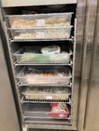
Allergen cross-contamination can happen unintentionally when there is a risk that the allergen has entered the product accidentally during the production process. This can sometimes happen when several food products are made on the same premises. Many food safety controls in place for other risks are also effective for food allergens.
Allergen segregation is possible by:
- Effective cleaning, washing up and hand washing using hot water, cleaning and sanitising products.
- Physical separation – putting a lid or cover on food, using a clean knife, board, plate, pan, working area, aprons.
- Using separate fryers/cooking equipment/tongs.
- Checking that packaging is clean and allergen spillage carefully managed.
- Careful management of dishwashing equipment – correct temperatures, products and cleaning.
- Using the same cooking oil.
- Using the same frothing wands and inadequate cleaning of wands.

Allergen information and labelling
There are a number of ways in which allergen information can be provided to your customers. You will need to choose the method which is best for your business and the type of food you serve.
There are three types of food when it comes to packaging:
Prepacked - Means any single item for presentation as such to the final consumer. consisting of a food and the packaging into which it was put before being offered for sale, whether such packaging encloses the food completely or only partially, but in any event in such a way that the contents cannot be altered without opening or changing the packaging.
Prepacked for Direct Sale – Prepacked for direct sale or PPDS is food that is packaged at the same place it is offered or sold to consumers and is in this packaging before it is ordered or selected. These are food stuffs you bag or package up yourself in advance of any customer order.
Loose – The item of food isn’t in any packaging until you put them into bags at the request of the customer.

Allergen information can be supplied on the menu, chalk boards, tickets or provided face-to-face. If provided in this way, make it clear that the information can be obtained by asking a member of staff by means of a notice, statement on the menu, ticket or label that can easily be seen by customers, as well as in other formats made available to the consumer e.g. on website, on an events booking form providing the customer has been made aware that the information is available. The notice must be clear and conspicuous, not hidden away and easily visible and legible. It is also best practise for staff to ask customers if they have any allergens when taking the orders and recording this on the order ticket or system.
For loose foods allergen information can be supplied on the menu.
For takeaways, the mandatory allergen information must be made available at point of order and delivery. Allergen information must be specific to the food, complete and accurate. Inaccurate or incomplete information about allergenic ingredients used in foods sold non-pre-packed (or prepacked for direct sale) would be a breach of the regulations and could result in penalties.
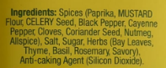
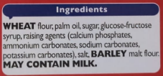
For prepacked for prepacked for direct sale food the allergen information must be given within the ingredients list. The information should be emphasised in some manner, commonly bold font can be used and you should use the legal name of the allergen (as above). E.g. pistachio (nut), prawns (crustacean).
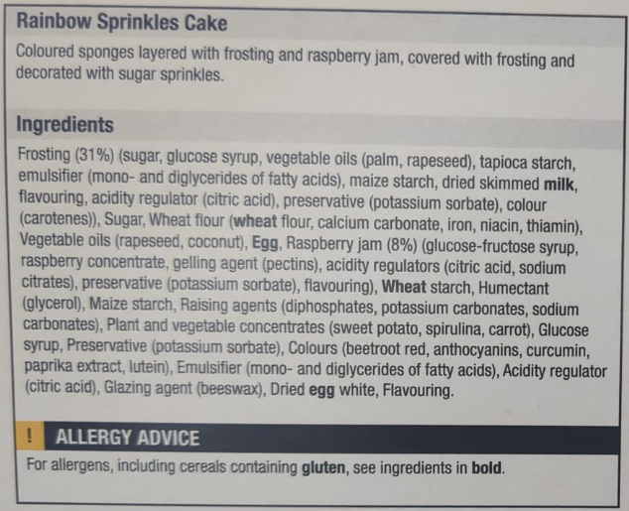

Allergic reaction: Emergency protocol for anaphylaxis
If someone is finding it hard to breathe, if their lips or mouth are swollen, or if they collapse, you should:
- Lie the person down and raise their legs – unless they’re having breathing difficulties and need to sit up to help them breathe. If they’re pregnant lie them down on their left side
- Call 999 immediately and state “Anaphylaxis”.
- Check if the customer has an adrenaline auto-injector and can self-administer into their thigh.
- Unless you have received specific training in its correct use, do not administer the auto-injector. The customer may have a family member or friend who can help.
- Send someone outside to wait for the ambulance, and stay with the person until qualified help arrives.

Further information
Allergen eLearning training is also available from the Food Standards Agency and Business Companion:
https://allergytraining.food.gov.uk/
www.businesscompanion.info/en/quick-guides/food-and-drink/food-allergens-and-intolerance
Further advice can always be sought from Trading Standards or Environmental Heath Teams.
BBfA also has labelling guide as part of this pack.

Preventing cross-contamination
There are a number of human infections that occur from exposure to ready to eat food contaminated with soil and raw foods. These include Salmonella enterica, Listeria monocytogenes (L. monocytogenes) Campylobacter spp., Clostridium perfringens, Escherichia coli (food-born gastrointestinal disease), Shigella spp
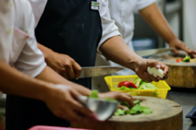
E. coli O157 in particular is a bacterium of concern because it can cause infections in very low doses – less than 10 bacteria. It can survive refrigeration and freezing and has been shown to be tolerant of acid, salt and dry conditions. The infection can be fatal and is not limited to raw meat but also uncooked flour, raw vegetables and salads.

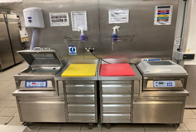
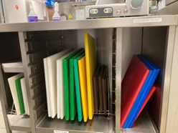
Preventing contamination
Businesses should ensure that work areas, surfaces and equipment used for raw and ready-to-eat food are adequately separated. This can be done by separating raw and ready-to-eat food processing, separating rooms, staff, utensils and equipment.
If this is not possible then you can clean and disinfect areas that are used for both raw and ready-to-eat food. Raw and RTE foods can only be prepared on shared surfaces at separate times, with cleaning and disinfection in between uses. This method carries the most risk and you must follow specific legal requirements to ensure that food is safe.

Equipment
Complex equipment such as vacuum packing machines, slicers and mincers shouldn’t be used for both raw and ready-to-eat food during a normal business day. Ensure you have one machine dedicated for each of these operations.

Personal hygiene
Staff must wash hands using a recognised technique. Anti-bacterial hand gels must not be used to replace handwashing but can be used following handwashing as an additional level of protection.
Gloves are not a substitute for effective handwashing. If gloves are used, they should be changed as often as you should wash hands and you must wash your hands when changing or removing gloves.
Consider use of disposable aprons (or changing apron following raw preparation) and roll up sleeves when preparing potentially contaminated raw food.

Disinfection
If you are using a chemical disinfectant or sanitiser, these must meet officially recognised standards and should be used as instructed by the manufacturer.

To effectively disinfect areas used for both raw and RTE foods, a two stage cleaning process must be followed:
Stage 1: use a detergent to clean and remove any visible dirt followed by rinsing with clean water
Stage 2: disinfect using a disinfectant at the correct dilution and contact time recommended by the chemical manufacturer.

Sanitisers can be used as both a detergent and a disinfectant. When using sanitisers, the two-stage cleaning and disinfection process, as described above, must still be carried out. You should apply the sanitiser first to provide a clean surface and then again to disinfect.

Disinfectants and sanitisers must at least meet the requirements of one of the following standards:
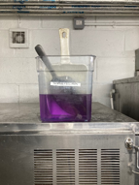
BS EN 1276 or BS EN 13697; or other standards that meet the same conditions and requirements.

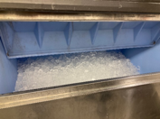
Regularly change sanitising solutions

Ice machines disinfected weekly.

Delivery and collection
Plan delivery times so that, if possible, raw foods arrive at different times to other foods. If delivered together, raw and ready-to-eat foods must be kept separate.

Storage
Ideally, store raw and ready-to-eat food in separate fridges, freezers and display units. If they are in the same unit, store raw meat, poultry, fish and eggs below ready-to-eat food. Unwashed fruit and vegetables should also be kept separate from ready-to-eat food and above raw meat.
Use either separate containers for raw & ready-to-eat foods or clean and heat disinfect between uses i.e using hot water or a dishwasher.
Cover cooked foods and other raw and ready-to-eat food using lids, foil or cling film. Coverings for raw and ready to eat foods should be kept separate.

Defrosting
Keep raw foods that are defrosting in the fridge in a covered container, below ready-to-eat food, or in a separate area of the kitchen away from other foods.

Preparation
Prepare raw foods in different areas. If this is not possible, separate by preparing them at different times to ready-to-eat foods and thoroughly clean and disinfect between tasks using the ‘2 stage clean’.
Where possible, ready-to-eat food preparation should take place before raw food preparation.
Dedicated colour coded chopping boards and utensils should be used.
* Do not wash raw meat or poultry.

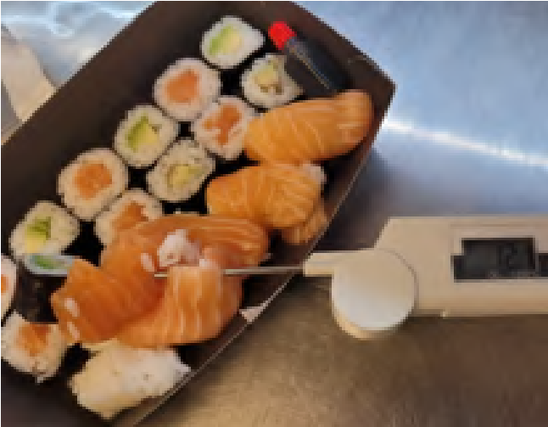
Procedure for Safe Production of Sushi and Sashimi SOP
Sushi: Food made from cooked rice which has been flavoured with vinegar, pressed into shape and rolled with other ingredients including raw or cooked seafood, vegetables, cooked meat, cooked egg and seaweed.
Sashimi: Food made from seafood including fillets of marine fish, molluscs, crustaceans, fish roe intended to be eaten raw.
Food Safety Risks With Sushi and Sashimi:
Production of sushi and sashimi dishes require specific food safety controls because:
- Dishes are prepared raw ingredients with no cooking process to kill any parasites or food poisoning bacteria that may be present.
- Raw seafood (whether it is fresh or frozen) can contain parasites and food poisoning bacteria which can be transmitted to consumers if the foods do not go through a safe cooking process.
- Dishes containing cooked, pressed rice may involve the cooked rice ingredient being held out of temperature control for periods of time (the rice is easier to press into shape when it is at room temperature) and if not handled correctly Bacillus cereus may form spores and toxins.
How to Produce Sushi and Sashimi Safely:
General Hygiene:
- Practice excellent personal hygiene including regular hand washing using soap and warm water immediately before food preparation. Dry hands with disposable paper towels.
- Store raw foods separately from ready to eat food to avoid cross-contamination. Where ingredients are used in their raw state these should also be stored away from or above other raw foods (such as raw meat).
- Defrost ingredients in small amounts as you require them. Ensure chilled ingredients are indate, and follow a stock control system based on the ‘first in, first out’ principle or individually date code your products with a preparation and use/dispose of date.
- Wash fresh fish, rice and vegetables before use.
- Keep food preparation areas and food equipment clean and disinfected (using a food safe sanitiser, or dishwasher at above 82ºC).
- Cook any egg or meat used to above 75ºC or to a point where you can tell visually that they are thoroughly cooked.
- Minimise preparation time and store or display any prepared Sushi and Sashimi at or below 4ºC, until it is served.
NB: The above guidance to keep prepared Sushi and Sashimi below 4ºC is for good practice. The Food Hygiene (England) Regulations 2013 requires food that can support the growth of pathogenic micro-organisms or the formation of toxins to be held at or below 8ºC. However, it would be a defence for you, if you can prove that the Sushi/Sashimi kept for service or on display at a temperature above 8ºC, but below 63ºC, was for less than 2 hours if the rice is to be served warm, such as straight from the rice cooker/warmer; or for less than 4 hours it the product is served chilled, i.e. from the fridge.
*However, to use either the “2-hour” or “4-hour” rule as a defence against a failure to keep the food at or below 8°C, you will have to show that you have a system for monitoring the length of time each food has been out of temperature control for i.e. to prove that it was less than 2 hours for warm/hot food or less than 4 hours for chilled food. Such a system must be documented and stated clearly within your food safety management system.
- All the safety procedures that you put in place to produce the food that you sell must be documented as part of your food safety management system.
Fish:
- Use good quality ingredients from reputable suppliers.
- Carry out visual inspections (at delivery and during preparation) of the fish to ensure that they are free of parasites. However, be aware that Tapeworms and flukes may not always be visible so this method is not 100% effective.
- Freezing raw fish will kill any tapeworm larvae present. However for this to work effectively the raw fish must be frozen so that it reaches at least -20ºC or colder for at least 24 hours or -35 ºC for at least 15 hours. This is a Legal Requirement. (See below for more information.)
- If the manufacturer / supplier of the fish has carried out the appropriate freezing process to eliminate parasites there should be a record of this with the consignment. It is a legal requirement for records of processes, such as freezing, to follow the product consignment.
- If there is no paperwork with the fish to show that the manufacturer / supplier has carried out the appropriate freezing process (or an equivalent procedure to kill parasites), you must do it yourself. You will need to keep evidence of this.
- After freezing, defrost the fish in a chiller. If you cannot achieve -2ºC for at least 24 hours, do not use raw fish. It must be cooked.
LEGAL REQUIREMENTS REGARDING FISH TO BE EATEN RAW OR ALMOST RAW
COMMISSION REGULATION (EU) No 1276/2011, which amends Annex III to Regulation (EC) No 853/2004.
As already stated above, there are specific requirements concerning the control of parasites in fish where the fish is to be consumed raw. This is of particular relevance to suppliers and caterers dealing in Sushi or Sashimi.
The following fishery products must be frozen at a temperature of not more than -20ºC in all parts of the product for no less than 24 hours or -35 ºC for not less than 15 hours. This treatment can be applied to the raw product or the finished product:
- fishery products intended to be consumed raw; or
- marinated, salted and any other treated fishery products, if the treatment is insufficient to kill the viable parasite;
If the fish has been frozen before arriving with your business, it must have with it documentation, showing what process it has undergone. This will identify for you whether the freezing process was sufficient to comply with the requirement above. If it is, you need not take any further action. If not, you must ensure that the fish is frozen to the levels stated above. You must keep this documentation easily retrievable as evidence. Ideally, it should be kept with the monitoring records for your food safety management system.
You need not carry out the freezing treatment set out above, if: -
- The fish are from wild catches, and provided that:
  - There are epidemiological data available indicating that the fishing grounds of origin do not present a health hazard with regard to the presence of parasites;
And
  - The competent authority so authorises;
- The fish are derived from fish farming, cultured from embryos and have been fed exclusively on a diet that cannot contain viable parasites that present a health hazard, and one of the following requirements is complied with: -
  - The fish has been exclusively reared in an environment that is free from viable parasites; or
  - You are able to verify through procedures, approved by the competent authority, that the fishery products do not represent a health hazard with regard to the presence of viable parasites.
*Based on a recent study the Food Standards Agency (FSA) have declared an exemption from freezing for farmed and pellet fed Atlantic salmon.
Sushi Rice:
Once the Sushi rice is cooked it must be held at a temperature above 63ºC or chilled down to below 8ºC as soon as possible, unless using for immediate preparation. Any unused Sushi or Sashimi must be disposed of at the end of the day.
It is recognised that mixing sushi rice with vinegar and salt seasoning will increase the acidity of the mix, which in turn will help prevent the growth of bacteria such as Bacillus cereus and the formation of their toxins. This will enable it to be left out of temperature control for longer periods, such as when making the sushi or sashimi. However, if you rely on this you must:
- As part of your food safety management system (HACCP), you must have written down your procedure for ensuring the precise amounts of vinegar/salt you are using in your solution.
- The acidity i.e. the pH of the rice and vinegar mix must be checked. This acidity will have to be low enough to inhibit bacterial growth, i.e. below pH4.5. pH meters can be purchased from specialist stores or on-line. The pH must be checked for every batch and recorded or you must be able to show that it has been checked in some other way e.g. by using a bought in solution that has been tested by a manufacturer and following manufacturer’s instructions.
*If you are not able to standardise your vinegar/salt solution for the Sushi rice and/or you are not able to check the pH level to ensure that it is below pH4.5, you must not allow the rice to be out of temperature.
You are therefore advised to prepare only small amounts in advance, chill them down, store in the refrigerator and allow them to warm up to room temperature naturally just before service.
**Using the correct solution of vinegar to reduce the pH of Sushi rice to pH4.5 or lower, should help to inhibit the growth of pathogenic bacteria such as Bacillus Cereus, which is commonly found in rice.
However, you must still ensure that you protect the rice against physical and chemical contamination. Additionally, you must remember that it is only the Sushi rice that is mixed with the vinegar solution. Any other food e.g. fish, meat or egg, added to the product, will not be protected and must not be left out at room temperature.

The Inspection
Catering from home falls under the Food Safety and Hygiene (England) Regulations 2013 and Retained Regulation (EC) No 852/2004. These Regulations lay down the requirements relating to persons engaged in the handling of food, the methods and practices used in food businesses and structural matters in food premises.
This is broken down into three areas: Management, Hygiene and Structure
The standards you will have to meet depend upon a number of factors such as the type and quantity of food you intend to prepare, and what else the kitchen is used for, however the following has been produced as a guide on what is expected in most cases to meet the requirements of food law.

Management

Food Safety Management System
All food businesses are required to think about how you will prevent the food that you prepare from being contaminated and ensure it is safe to eat. Contamination falls into three categories: Chemical; Physical and Microbiological.
Hazard | Example
Chemical Contamination | Using cleaning materials that are not ‘food safe’ / storing chemicals around food
Microbiological  Contamination | Not cooking food properly / leaving high risk food (such as fresh cream) out at room temperature / storing baked goods below raw foods causing cross contamination
Physical Contamination | Items falling into bakes (hair/nail varnish) / poor structure of the kitchen (peeling paint/damaged sink seals) / pest control / allergen contamination
You are required to have a simple written system in place which shows how you will control these problems. The Food Safety team have produced a short document which you can use to meet this requirement. Complete the blanks in this document to form a food safety management system.

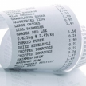
Traceability
You need to make sure that you can show where all of your ingredients have come from and where your cakes have gone to. Keep hold of all receipts for ingredients brought and keep a record of your customers and dates sold.

Training
The law requires you to have suitable and sufficient knowledge to ensure that you prepare food safely. You may wish to undertake a food hygiene training course to help achieve this. Courses can be done online or in person.

Use By/Best Before Dates
Cakes and biscuits sold in supermarkets are often full of preservatives and may have been specially packed to allow the products to have an extended shelf life.
Best before/use by dates can only be established by microbiological testing of a product.
As this is something which is costly, we suggest a short shelf life erring on the side of caution. Whilst this is a low-risk product, there could be mould growth and loss of cake quality. You may wish to do some trials (taste and quality) which will help you to confirm this, although you must bear in mind the fact that you can not see bacteria. As a general rule, we would recommend that products are given a shelf life of day of production +2.

Hygiene

Sinks And Hand Washing
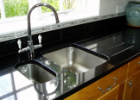
Most people do not have a separate wash hand basin in their kitchen. You must ensure that you do however have “adequate facilities for the cleaning of utensils and maintaining adequate personal hygiene”.
If you are fortunate enough to be having a new kitchen or sink fitted, we recommend that you install a 1½ or double sink unit. One of these units can then be designated solely for hand washing.
If you only have one sink, you need to consider how you can meet this requirement.
As you will be using your sink in your household’s day to day activities, you must ensure that before you start undertaking any baking that you thoroughly clean and disinfect the sink, taps and surrounding area. It can then be used for hand washing whilst you bake.
If utensils are washed in the sink, you must ensure that again the procedure for cleaning and sanitising the sink after use are implemented.


Norovirus And Fitness To Work
48
You do not want to be the cause of an outbreak of norovirus or food poisoning (sickness and diarrhoea illness) at a function you have prepared cakes for!
If you suffer from sickness and/or diarrhoea you must ensure that you are symptom free (no sickness and/or diarrhoea) for 48 hours before you undertake any baking or cake preparation.
Take the time to consider now what you would do if you had a large order to fulfil and came down ill.

High Risk Baking
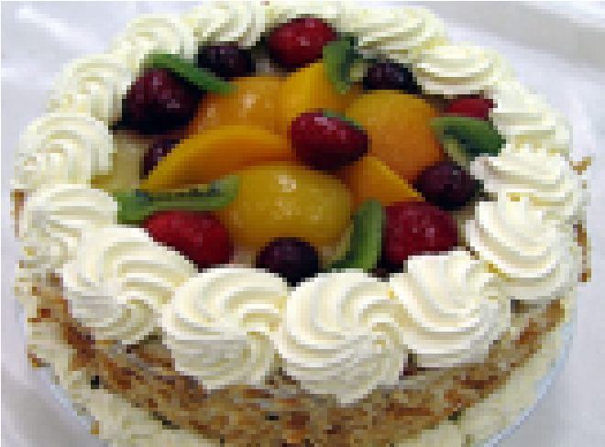
Although most cakes and biscuits are classed as low risk products, some fillings and finishes are more high risk. Fresh cream, some cheesecakes and royal icing made from raw egg whites are all high risk and require extra thought to ensure they are prepared safely.
Cakes that require refrigeration must be kept at or below 8°C at all times with limited time out of temperature control (maximum 4 hours in total).
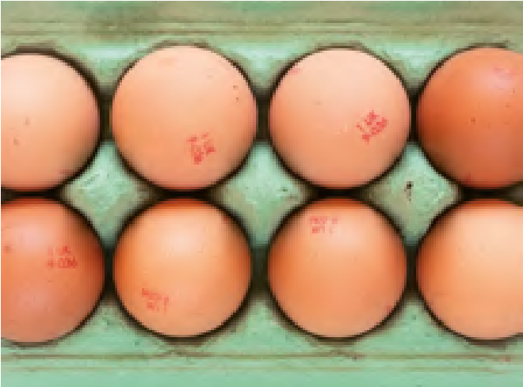
Royal icing is traditionally produced using raw egg whites. This method can still be used, however we would recommend that lion marked eggs are used, and that these products are not given to vulnerable groups (the young, elderly or pregnant). You can now purchase pasteurised dried egg whites or pasteurised royal icing mixes which remove this risk.

Fridge
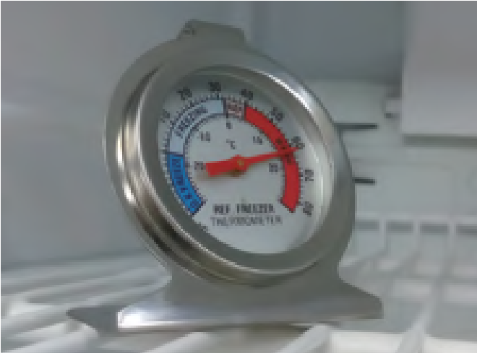
Any items being kept in the fridge must be stored in a way which does not cause contamination.
Raw meat and unwashed salad and vegetables must be stored below ready to eat foods at all times.
You must ensure that your fridge is well organised and running at a temperature of 8°C or below. Use a fridge thermometer to check the temperature regularly.
Don’t overload your fridge. The efficiency of the fridge will suffer if the cooling air circulating within it cannot flow freely.
Keep the fridge door closed as much as possible. Leaving the fridge door open raises the temperature.
If you prepare a large amount of food that needs to be kept in the fridge you may need a separate fridge which is only used for your business.

E-Coli
Making cakes is a low-risk activity, however if you prepare raw meat and unwashed salad and vegetables in your home you could be causing an e-coli risk. You must take care when preparing your food at home to ensure that unwashed salads/vegetables and raw meats are never prepared on the same surfaces as ready to eat foods.
You must make sure that before you begin work that your kitchen is prepared to be your “working kitchen”. This will generally mean removing anything not required in the kitchen and thoroughly cleaning and sanitising the surfaces.
E. coli bacteria and other food poisoning bacteria can grow on the tiniest food source on a dirty work surface. Proper cleaning and sanitising should also remove all the bacteria from surfaces and equipment involved in food preparation.

Cleaning Chemicals
You must ensure that you have appropriate cleaning chemicals to keep the kitchen clean and sanitise surfaces and equipment. Antibacterial sprays and sanitisers should meet a certain British Standard (BS EN: 1276 or 13697) if you are unsure whether your current sprays meet this requirement you may wish to visit: www.disinfectant-info.co.uk
Different types of disinfectants require different dilutions and contact times. These are specified and validated by the manufacturer and you must follow the manufacturer’s instructions for dilution and contact time to ensure the product is effective.

Structure

Your Kitchen
You must ensure that the structure of your kitchen is kept clean and maintained in good repair and condition as to avoid the risk of contamination.
Walls | need to be a smooth impervious finish (for example tiled or smooth plaster painted with a gloss or silk vinyl paint)
Floors | need to be smooth, impervious, non-absorbent, washable and of non-toxic material  (for example sealed lino or sealed floor tiles with water proof joints)
Ceiling | need to be smooth, impervious, non-absorbent, washable and of non-toxic material

Toilets
Toilets should not open directly into your kitchen. However in some houses, such as those built in Victorian times the toilet leads straight from the kitchen and cannot be avoided. In these situations, you must ensure that the toilet is well ventilated and the door to the toilet kept shut. People should not use the toilet whilst you are baking.

Ventilation
You must ensure that you have adequate ventilation in place in the kitchen to prevent condensation, mould growth, and damage to decoration – but make sure open windows don’t create a problem with flies and pests!

Equipment
All equipment must be in good condition and not be a potential source of contamination due to its condition or cleanliness.
All equipment should be carefully cleaned, sanitised and stored. You must regularly check equipment and repair/replace anything damaged.

Pest Control
You must ensure that your kitchen is always pest free. This can be achieved with regular checking of the kitchen for evidence of pests (droppings/nibbled food).
Making sure that no food is left out and that the kitchen is kept in a clean condition at all times.
Any signs of pest activity should be treated straight away. It is a good idea to record any problems you have and what you did about the problem.

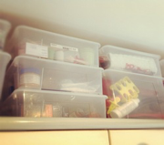
Storage
You need to ensure that at all stages of storage, production and delivery the cakes that you produce are free from microbiological, chemical and physical contamination.
Storing equipment, tins and ingredients should be kept separately from your day-to-day items wherever possible. Lidded containers are useful for preventing contaminants falling into tins/equipment whilst it is being stored.
Food in the fridge should be wrapped/covered to prevent items falling/dripping onto others.

Other Considerations

Pets
Having pets is absolutely fine! However, you must consider this as part of how you prevent any animal hair etc from ending up in the food you prepare.
Pets must not be allowed in the kitchen when you are preparing food.
All surfaces/equipment that they may have come into contact with must be thoroughly cleaned and sanitised prior to you beginning a baking session.

Washing Machines
A common query is that of having a washing machine in the kitchen. We understand that washing machines are generally in domestic kitchens, you therefore need to consider this and ensure that no washing is undertaken at the same time as you prepare food for the business.

Edible Decorations
The Food Standards Agency have issued guidance on the use of glitters and dusts on cakes. Only glitter or dust clearly labelled as ‘edible’ should be applied to food for consumption.

Eggs
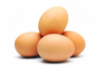
We all know that cake makers prefer to use eggs that are at room temperature. It is best to keep eggs in the fridge and to get them out a few hours prior to baking to bring them up to room temperature. Leaving eggs out at room temperature in your kitchen exposes the eggs to lots of changes in temperature, keeping them in the fridge keeps them at a constant temperature.
Eggs which are Lion Marked meet a specific safety standard. We recommend that you use eggs with this marking.
EU Food Information Regulation 1169/2001 (FIR)
It is a legal requirement for all caterers to provide information on any allergens used.

